Always On configuration step by step

1. Enable always on feature.

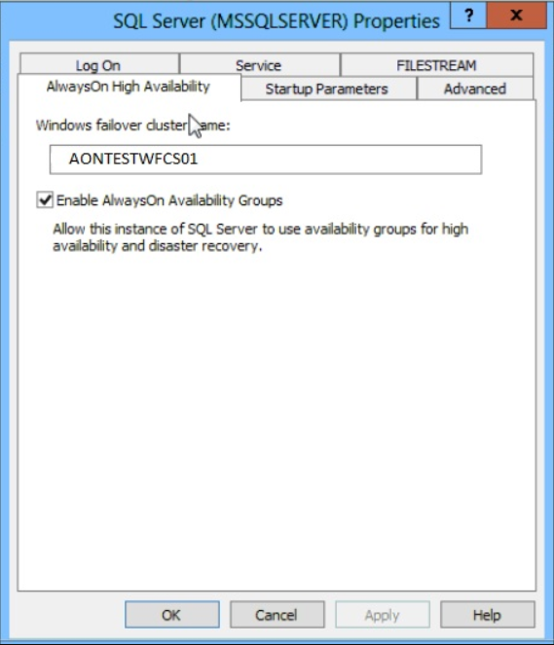

1. right click availability group:

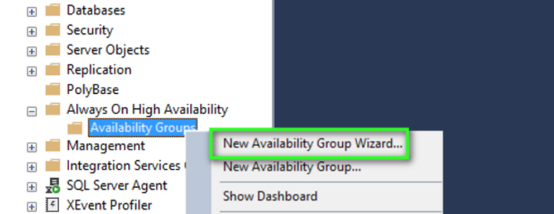

1. give the availability name:

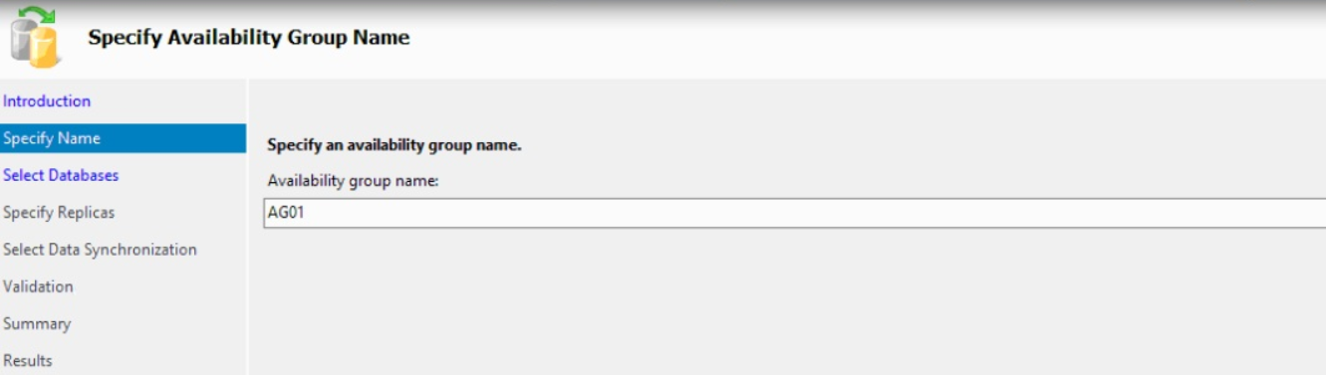

1. select the databases

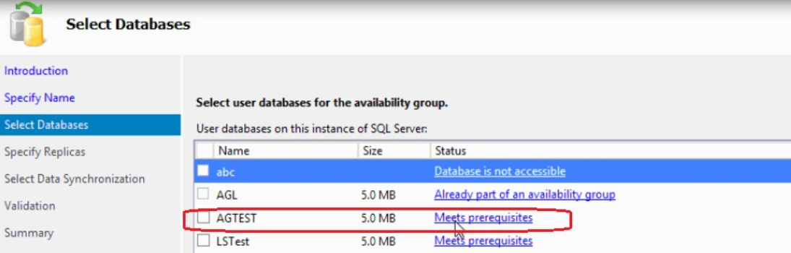

1. Select the replicas:

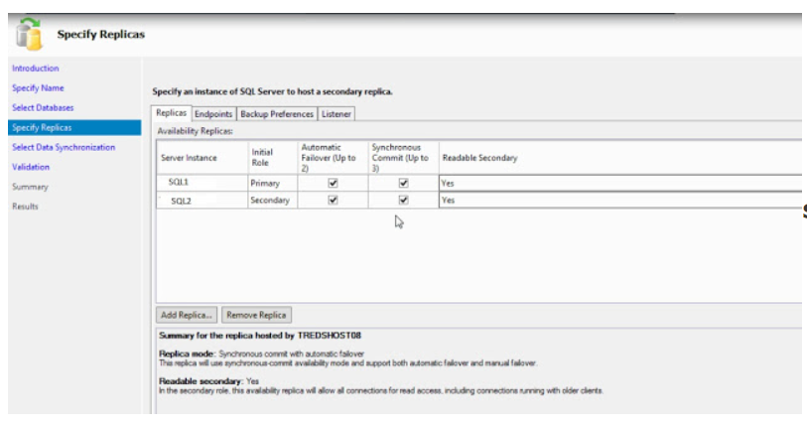

1. Select the endpoints:

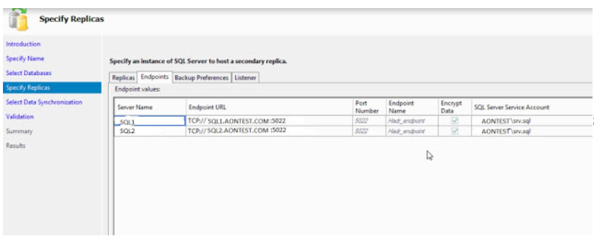

1. Select the backup preference:

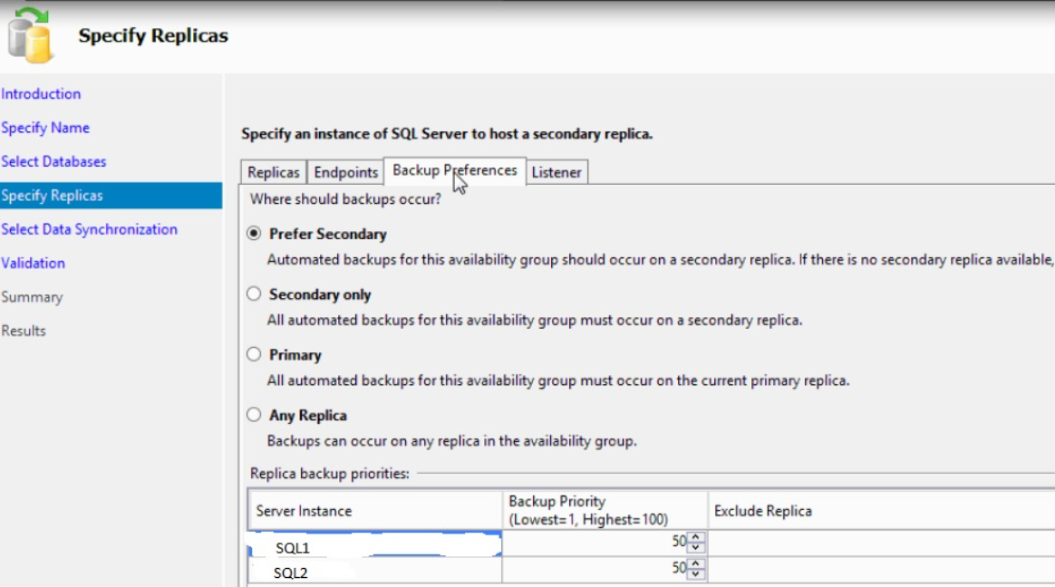

1. Select the preference db adding automatic seeding.
2. Check validation and once done configured completed.

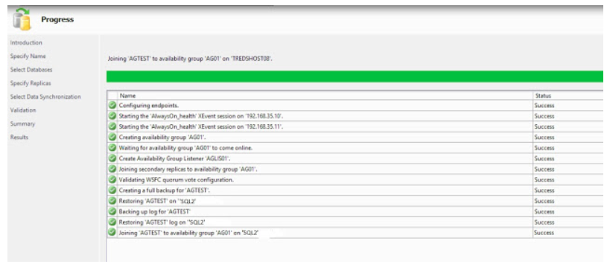

Verify all configuration settings and click Finish. This will create and configure the Always On Availability Group and join the databases.